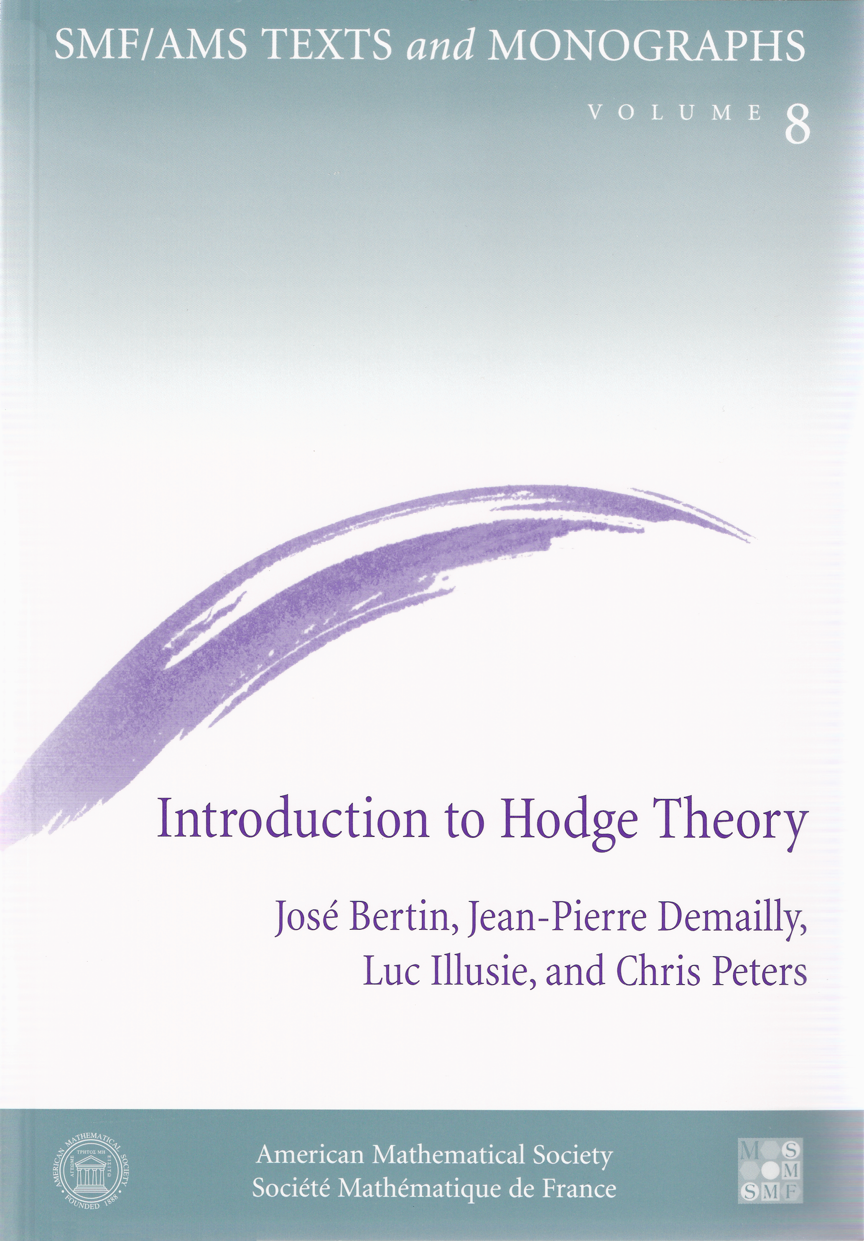

Selected titles in This Series

Volume

8 José Bertin, Jean-Pierre Demailly, Luc Illusie, and Chris Peters
Introduction to Hodge theory (2002)

7 Jean-Pierre Otal
The hyperbolization theorem for fibered 3-manifolds (2001)

6 Laurent Manivel
Symmetric functions. Schubert polynomials and degeneracy loci (2001)

5 Daniel Alpay
The Schur algorithm, reproducing kernel spaces and system theory (2001)

4 Patrick le Calvez
Dynamical properties of diffeomorphisms of the annulus and of the torus (2000)

3 Bernadette Perrin-Riou
p-adic functions and p-adic representations (2000)

2 Michel Zinsmeister
Thermodynamic formalism and holomorphic dynamical systems (2000)

1 Claire Voisin
Mirror symmetry (1999)

Introduction to Hodge Theory

SMF/AMS TEXTS and MONOGRAPHS • Volume 8
Panoramas et Synthèses • Numéro 3 • 1996

Introduction to Hodge Theory
Jose Bertin, Jean-Pierre Demailly,
Luc Illusie, and Chris Peters
Translated by
James Lewis
Chris Peters



American Mathematical Society
Société Mathématique de France
Introduction à la Théorie de Hodge
(Introduction to Hodge Theory)
by José Bertin, Jean-Pierre Demailly, Luc Illusie, and Chris Peters
Originally published in French by Société Mathématique de France.
Copyright @ 1996 Societe Mathematique de France
L2 Hodge theory and vanishing theorems by Jean-Pierre Demailly and Frobenius and Hodge degeneration by Luc Illusie were translated from the French by James Lewis.
Variations of Hodge structure. Calabi- Yau manifolds and, mirror symmetry by José Bertin and Chris Peters was translated from the French by Chris Peters.
2000 Mathematics Subject Classification. Primary 14C30, 14D07, 14F17, 13A35, 58A14,
14-02, 32-02; Secondary 81-02.
Abstract. Hodge theory is a powerful tool in analytic and algebraic geometry. This book consists of expositions of aspects of modern Hodge theory, with the purpose of providing the nonexpert reader with a clear idea of the current state of the subject. The three main topics are: L2 Hodge theory and vanishing theorems; Hodge theory in characteristic p; and variations of Hodge structures and mirror symmetry. Each section has a detailed introduction and numerous references. Many open problems are also included. The reader should have some familiarity with differential and algebraic geometry, with other prerequisites varying by chapter. The book is suitable as an accompaniment to a second course in algebraic geometry. This is the English translation of a volume previously published as volume 3 in the Panoramas et Synthèses series.
Library of Congress Cataloging-in-Publication Data
[Introduction à la théorie de Hodge. English.]
Introduction to Hodge theory / Jose Bertin ... [et ah] ; translated by James Lewis, Chris Peters.
p. cm. — (SMF/AMS texts and monographs, ISSN 1525-2302 ; 8) (Panoramas et synthèses ; n. 3, 1996)
Includes bibliographical references.
ISBN 0-8218-2040-0
1. Hodge theory. I. Bertin, Jose. II. Series. III. Panoramas et syntheses ; 3.
QA564.15913 2002
516.3'5 — dc21 2002019611
Copying and reprinting. Individual readers of this publication, and nonprofit libraries acting for them, are permitted to make fair use of the material, such as to copy a chapter for use in teaching or research. Permission is granted to quote brief passages from this publication in reviews, provided the customary acknowledgment of the source is given.
Republication, systematic copying, or multiple reproduction of any material in this publication is permitted only under license from the American Mathematical Society. Requests for such permission should be addressed to the Acquisitions Department, American Mathematical Society, P. O. Box 6248, Providence, Rhode Island 02940-6248. Requests can also be made by e-mail to reprint-permission@ams.org.
© 2002 by the American Mathematical Society. All rights reserved.
The American Mathematical Society retains all rights
except those granted to the United States Government.
Printed in the United States of America.
@ The paper used in this book is acid-free and falls within the guidelines
established to ensure permanence and durability.
Visit the AMS home page at URL: http://www.ams.org/

10 987654321 07 06 05 04 03 02
vii CONTENTS

Foreword | ix

L² Hodge Theory and Vanishing Theorems |  | 1
 | Jean-Pierre Demailly
 | 0. Introduction | 5
Part I. L² Hodge Theory |  | 9
 | 1. Vector bundles, connections and curvature | 9
 | 2. Differential operators on vector bundles | 12
 | 3. Fundamental results on elliptic operators | 14
 | 4. Hodge theory of compact Riemannian manifolds | 19
 | 5. Hermitian and Kähler manifolds | 24
 | 6. Fundamental identities of Kählerian geometry | 27
 | 7. The groups H ^{p,q}(X,E) and Serre duality | 35
 | 8. Cohomology of compact Kähler manifolds | 36
 | 9. The Hodge-Frölicher spectral sequence | 42
 | 10. deformations and the semi-continuity theorem | 47
Part II. L² estimates and vanishing theorems |  | 53
 | 11. Concepts of pseudoconvexity and of positivity | 53
 | 12. Hodge theory of complete Kähler manifolds | 60
 | 13. Bochner techniques and vanishing theorems | 70
 | 14. L² estimates and existence theorems | 73
 | 15. Vanishing theorems of Nadel and Kawamata-Viehweg | 75
 | 16. On the conjecture of Fujita | 82
 | 17. An effective version of Matsusaka's big theorem | 89
Bibliography |  | 95

vii
viii CONTENTS

Frobenius and Hodge Degeneration |  | 99
 | Luc Illusie
 | 0. Introduction | 101
 | 1. Schemes: differentials, the de Rham complex | 103
 | 2. Smoothness and liftings | 107
 | 3. Frobenius and Cartier isomorphism | 113
 | 4. Derived categories and spectral sequences | 119
 | 5. Decomposition, degeneration and vanishing theorems in characteristic p > 0 | 124
 | 6. From characteristic p > 0 to characteristic zero | 130
 | 7. Recent developments and open problems | 137
 | 8. Appendix: parallelizability and ordinarity | 143
Bibliography |  | 147

Variations of Hodge Structure, Calabi-Yau Manifolds and Mirror Symmetry |  | 151
 | José Bertin and Chris Peters
 | 0. Introduction | 155
Part I. Variations of Hodge structures |  | 161
 | 1. Hodge bundles | 161
 | 2. Gauss-Manin connection | 163
 | 3. Variation of Hodge structures | 172
 | 4. Degenerations | 179
 | 5. Higgs bundles | 187
 | 6. Hodge modules | 188
Part II. Mirror symmetry and Calabi-Yau manifolds |  | 193
 | 7. Introduction to mirror symmetry | 193
 | 8. Cohomology of hypersurfaces | 199
 | 9. Picard-Fuchs equations | 205
 | 10. Calabi-Yau threefolds and mirror symmetry | 210
 | 11. Relation with mixed Hodge theory | 222
Bibliography |  | 229

viii
Foreword

Each of the three chapters collected in this book is concerned with various aspects – important ones in several respects – of Hodge theory. The text is an expanded version, including substantial additions, of lectures presented on the occasion of the meeting “l'Etat de la Recherche” devoted to Hodge theory, that has been held at Université Joseph Fourier in Grenoble from Friday November 25, 1994 till Sunday November 27, under the auspices of the SMF (Société Mathématique de France). The authors wishes would be fulfilled if, in accordance with the general goals of sessions “l'Etat de la Recherche”, this book could help the nonexpert reader to get a precise idea of the current status of Hodge theory.

The three main subjects developed here (L² Hodge theory and vanishing theorems, Frobenius and Hodge degeneration, Variations of Hodge structures and mirror symmetry) cover a wide range of techniques: elliptic PDE theory, complex differential geometry, algebraic geometry in characteristic p, cohomological and sheaf-theoretic methods, deformation theory of complex varieties, Calabi-Yau manifolds, a few aspects of singularity theory ... This accumulation of tools arising from various fields probably makes the access to the theory rather uneasy for newcomers. We hope that the present book will greatly facilitate this access: a special effort has been made to approach various themes by their most natural starting point, each of the three chapters being supplemented with a detailed introduction and numerous references. The reader will find precise statements of quite a number of open problems which have been the subject of active research in the last years.

The authors are grateful to SMF and MESR (Ministère de l'Enseignement Supérieur et de la Recherche) for their decisive action – both psychological and financial – without which the Grenoble session “Hodge theory” would probably never have taken place. They address special thanks to the Scientific Committee of Sessions l'Etat de la Recherche, in behalf of its two successive directors Pierre Schapira and Colette Mœglin, as well as to Michèle Audin, Editor in Chief of the Journal “Panoramas et Synthèses”, for her strong encouragement to publish the present manuscript. Finally, they express their gratitude to the referee for his careful reading of the manuscript and a large number of invaluable suggestions.

November 27, 1995
José Bertin*, Jean-Pierre Demailly*. Luc Illusie**, Chris Peters*
* Université de Grenoble I, Institut Fourier,
BP 74, 38402 Saint-Martin d'Heres. France
** Université de Paris-Sud, Département de Mathématiques,
Bâtiment 425, 91405 Orsay. France
ix

