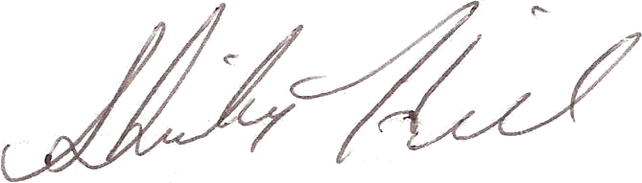

American Mathematical Society
P.O. Box 6248, Providence, RI 02940 - 6248 USA
201 Charles Street, Providence, RI 02904 - 2294
Phone: 401- 455- 4000, Fax: 401 - 331 - 3842
www.ams.org
Publications Division - Acquisitions
Shirley Hill, Acquisitions Assistant
Phone: 401-455-4044, Email: sxh@ams.org

April 17, 2000
Professor J. P. Demailly
Institute Fourier
University of Grenoble I
BP74
38402 St Martin dHeres Cedex
France
Dear Professor Demailly:
Please find enclosed the translation of "Introduction to Hodge Theory", translated by James Lewis. We would like you to read it and send us your approval, comments and corrections.
If it is possible we would like to hear form you within three weeks, this way production will not be interrupted.
A copy was also sent to Professor Luc Illusie.
Sincerely,
Shirley Hill

